**HITEC SCHOOLS & COLLEGES**

**SUMMER TASK FOR CLASS VI**

**SESSION 2022-23**

**Respected Parents!**

**Summer break is vacation time students eagerly wait for. So, now is the time to unlock the days creatively making the most while at home.**

**To ensure that children have a constructive holiday, some homework & projects have been given which will keep the child active and observant. These projects can easily be done by the children and you can assist only where required.**

**The activity based assignments will foster curiosity, develop creativity, enhance knowledge and instill the joy of learning among the students. They will certainly help to discover a new child who is more enriched and confident and performs every action to perfection.**

**Social Work Practice**Social work and community service is challenging and time consuming but highly rewarding.

Dear students! Our world is desperately waiting for a change. If each one of us does one little act of kindness, the world will become ***a better place to live in***. Let us take responsibility and put in our share.

**Plant a tree or a plant**: With depleting forests and increasing pollution, planting a tree/plant will help our environment. A single tree can absorb almost a ton of carbon dioxide during its lifetime. So, let us plant and give back, what we have taken away!

**Be Kind**: One of the easiest ways to be kind is – SMILE! The room lights up when we smile and so does the person, we give our smile to. Another method of spreading kindness is, look around for those less privileged than you. You will find so many in need of your love and care – Open your cupboard, there may be clothes or shoes that you have outgrown or do not wear any more. Put a dress or shoes (that you do not wear now) in a bag and give it to someone in need. It will make him/her very happy and you happier!

Make photos of these two activities, write your feelings, and paste in your summer task.



**ENGLISH**

* + - * **Read the following lessons carefully and note down the key points in the text ( Write down the points on sticky notes and paste with the relevant chapter )**
* Emails from across the world(Oxford Progressive English)
* Summers in Murree(Oxford Progressive English)
* **Study the following parts of speech and their kinds and make a presentation on any two.**

 Noun, Pronoun, Verb, Adverb

* **Vocabulary:**
* **Find meanings(from the dictionary) of the given words and use them in sentences of your own.**

Multicultural,monument,chapel,summit,shaggy,dome,manufacture,starve,expense,slum,rebellion,irritated,parish,nudge,beadle,straw,massive,endangering,suspected,amazed,capture,eager,escape,deforestation,exotic,excitement,condemned,sedative,unfortunate,commotion threatened

* **Unscramble the jumbled words**

Rgaoedn, htoguth, iedmexlac, luopewrf, twahc, manmcod, lesank, deror, venwo, ighne

* **NOVEL**
* **Read or watch on you tube 4 chapters of the reader (Gulliver's Travels) write a short summary of the story in your own words.<https://youtu.be/k091dxgD6qw>**
* **Story Writing:**

**Complete these stories and give them a proper ending.**

1. It was an ordinary day and Ali was on his way to the market. Turning a corner, he ran into an elderly man who dropped a small packet he was carrying on the pavement.....
2. As Samia walked to school, she knew that the day was going to be one of the most important days of her life.....
3. Rafia was going to be alone at home all day. While she was wondering how she could make the best use of the day, the door bell rang.....

* **Letter/application**

Write a letter to your sister/brother congratulating her/him on her/him success in exams.

Write a letter to your friend requesting her to go to the shopping mall with you.

Write an application to the principal requesting to provide a water cooler in the play ground of your school.

* **Write interesting paragraphs on the given topics**

a) A memorable day at the zoo

b) My promises for future

c) Relationships are important for me because....

**SCIENCE**

* 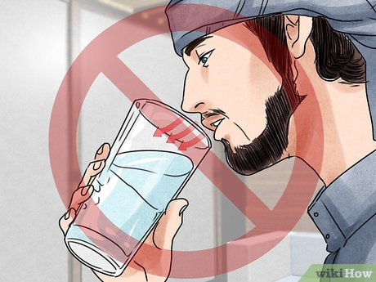Give scientific reasons of the following
* drinking water in sitting posture
* sleeping with right shoulder down
* eating posture with your right leg up
* What are the disadvantages of using commode?
* How are days and nights formed?
* Why is there a time difference in different countries?
* Under the same gravity a ball and feather take different time to reach earth. Why?
* As plants are living organisms so list the things they need as food?
* Why must oil tank of vehicles not be fully filled in summer
* 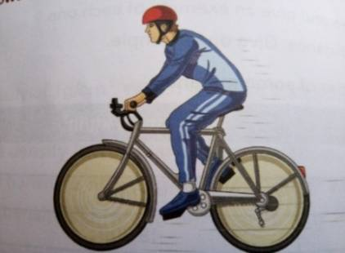As we all know that we are running out of energy resources. What role can you play to save the energy resources? (keep practicing those methods to save resources)
* Ships are so heavy but still float on water but a stone sinks. Why?
* Why do we need measuring instruments in our daily life?
* Why should we not exhale while drinking from a glass?
* **Reading**

Read the following chapters of **Science Book Fact File 1**and do the following activites

* Science Skills
* Life and Living Things
* **Activity#1**

**Measurement of volume:**

How do you find the volume of an irregular shaped object

* **Activity#2**

**Make a table**

Write down the characteristics of living and non-living things; draw the relevant images as well.

* **Activity#3**

News is circulating on media now a day that this year Pakistan only experienced two seasons summer and winter. We couldn’t enjoy the beauty of spring and autumn.

* What do you think is the reason of this drastic change in weather?
* Is this because of us? If yes, How?
* What role are you playing or can you play in reversing this change?
* Make a list of five habits which you have followed or are followingduring Summer Break to bring a change in this present alarming situation.

**MATHEMATICS**

* **Instructions**
* Make proper, well decorated file for your Maths task.
* Do your work very neatly and carefully by drawing proper margin lines, separation lines and ending lines.
* Use blue marker and blue pointer only.

Learn all definitions and practice different examples on daily basis.

* **Tasks**

1. **Learn and write all definitions with examples.**

Set, Elements of a set, Sets notations, Finite Set, Infinite set, Empty Set, Unit Set, Disjoint Sets, overlapping sets, Equal Sets, Equivalent sets.

1. **Learn and write all definitions with figures.**

Acute angle, Obtuse Angle, Reflex angle, Right angle,Complete angle, Straight angle.

1. **Learn tables of 2 to 15.**
2. **Download Kangaroo Math app and practice ten sums daily on mentioned app.Keep record of your obtained marks on loose sheets.**

|  |  |  |  |
| --- | --- | --- | --- |
| **Sr #** | **Date of Test** | **Total Marks** | **Obtained Marks** |

* **Project**

**Create a project by using different coloured hard sheets and markers which will explain the concept of any one of the following:**

1. Types of triangles and classification
2. Define variable, co-efficient, constant and algebraic expressions
3. Divisibility test for 2, 3, 5, 6,9 and 11

* 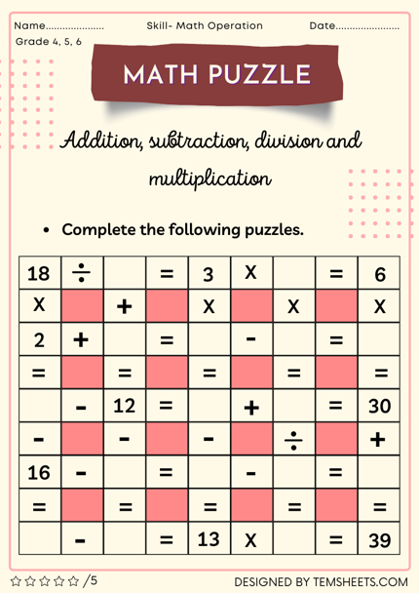**Complete the following puzzle**
* **Perform the division:** 
  1. (-63) ÷ 7
  2. (-56) ÷ (- 8)
  3. 112 ÷ (-7)
  4. (-231) ÷ (-11)
  5. (-365) ÷ (5)
* **Calculate LCM by division method:**

1. 45, 50
2. 16, 24
3. 6, 12, 24
4. 14, 21, 56
5. 32, 48, 72

* **Calculate the HCF by prime factorization:** 
  1. 36 and 84
  2. 60 and 96
* **Solve the following word problems:**

1. Emily obtained 380 marks out of 400. Calculate her percentage and grade.
2. If the time is 3’o clock. What would be the time after $2\frac{1}{2}$ hours?
3. If the length of your study table is 4 meters and its breadth is 12 meters. Find total area covered by your study table in meters.

**SOCIAL STUDIES**

**Reference Book: Secondary Social Studies For Pakistan Book I by Peter Moss**

**Geography:**

**Activity 1.** Write down five factors that are affecting the climate now a days. Illustrate with the help of diagrams.

**Activity 2.** Find out information about the major crops of Pakistan.

**Activity 3.** Why is butter difficult to store and transport in hot weather? Find out more about dairy products being made in Pakistan. List the names of some companies that make dairy products. Also find out the difference between Butter and Margarine, elaborate which out of the two is a healthier food choice.

**History:**

**Activity 4.**Write a note on historical importance of your city TAXILA, Who were the people that lived in Taxila before you, their lifestyle, beliefs, architecture, food etc

**Activity 5.** Make a time line, with dates, to show the rulers and events from Muhammad bin Qasim to Mughals.

**Activity 6**. Find information about TajMahal from reference books or websites--- its size, for example, and prepare a class display.

**Activity 7.** Can you suggest things that might have happened to make the people leave the subcontinent? Or had they gone before new invaders swept in?

**Activity 8.** Read articles on Muhammad bin Qasim and Sir Syed Ahmed Khan.

**اسلامیات**

ا**۔درج ذیل سورتوں کو خوشخط لکھیں ، ان کا بامحاورہ ترجمہ لکھیں اور یاد کریں**

ب**۔ سبق اللہ تعالیٰ پر ایمان کے حوالے سے ایمان مجمل اور ایمان مفصل کے عربی متن اور ترجمہ خوشخط لکھیں۔**

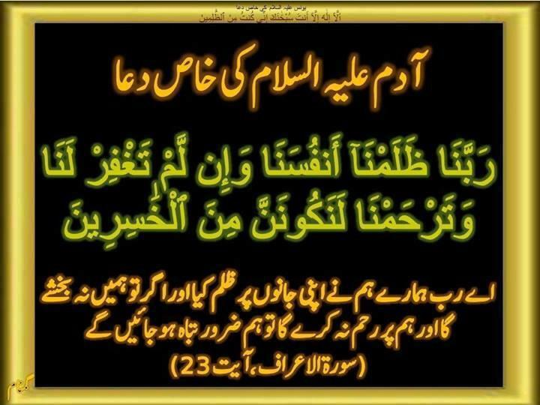**ج۔ اذان کے الفاظ کا عربی متن اور ترجمہ خوشخط لکھیں۔**

**2۔ فرائض نماز کی وضاحت کریں۔ ۔**

* **قرآنی دعاؤں کی خوشخطی اور ترجمہ بھی لکھیں۔**
* **مناسک حج کی تفصیل تحریر کریں۔طواف، سعی،رمی، وقوف عرفات**

**مندرجہ ذیل اسباق کو غور سے پڑھیں ان اسباق کے پانچ معروضی سوالات بنائیں اور ان کے جوابات بھی تحریر کریں۔**

**اسباق:۱۔اذان کی اہمیت اور فضیلت2۔نماز کی اہمیت ، فضیلت اور فرائض3۔ام المومنین حضرت خدیجہ ؓ**

**نوٹ:روزانہ پانچ وقت نماز پابندی کے ساتھ ادا کریں اور قرآن پاک کا پارہ نمبر ۷ تا ۱۲ کی تلاوت پابندی سےکریں**

**اردو**

**مضامین:**

**درج ذیل موضوعات پر کم از کم تیس (30) سطروں کا مضمون تحریر کریں۔**

1۔ مری(پہاڑی علاقہ) کی سیر 2۔ جنگلات کے فوائدو نقصانات

**کہانی نویسی:**

**درج ذیل تصاویر کی مدد سے کہانیاں تحریر کریں۔**

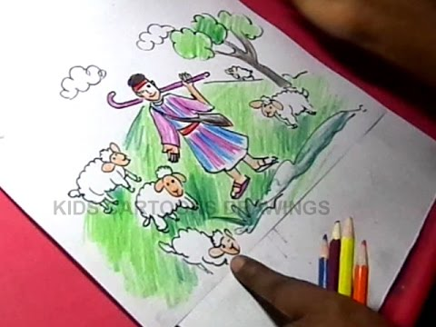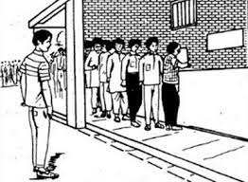

**خطوط نویسی:**

**٭۔ بڑے بھائی کے نام روز مرہ معمولا ت کی تفصیل بتانے کیلئے خط تحریر کریں۔**

**٭۔ سہیلی / دوست کے نام اپنے ساتھ چھٹیاں گزارنے کی دعوت دینے کیلئے خط تحریر کریں۔**

**درخواست نویسی:**

**٭۔ پرنسپل کےنام اپنے سکول میں سمر گالا کا اہتمام کرنے کیلئے درخواست تحریر کریں۔**

**٭۔ پرنسپل کے نام فیس معافی کی درخواست تحریر کریں۔**

**آپ بیتی:**

**کرسی کی آپ بیتی تحریر کریں۔**

**اشارات: میں عام سی لکڑی سے بنی ہوئی ۔۔۔۔۔۔میں مختلف مراحل سے گزر کر تیار ہوئی ہوں۔۔۔۔۔۔۔میں لوگوں کو آرام پہنچاتی ہوں۔۔۔۔۔۔**

**قواعدو انشا:**

**٭۔درج ذیل الفاظ و محاورات کو جملوں میں اس طرح استعمال کریں کہ ان کے معانی واضح ہو جائیں۔**

تن بدن میں آگ لگنا۔ ٹس سے مس نہ ہونا۔ جان میں جان آنا۔ خاک چھاننا۔ دال میں کالا ہونا۔شیروشکر ہونا۔ رفوچکر ہو جانا۔ طیش میں آنا۔ اظہار یکجہتی۔ حمدوثنا۔ آنکھیں چرانا۔ الو بولنا۔ بائیں ہاتھ کا کھیل ہونا۔ بڑا بول بولنا۔

**٭۔ مندرجہ ذیل متشابہ الفاظ کا فرق جملوں میں استعمال سے واضح کریں۔ اردو قواعد و انشا صفحہ نمبر81**

آم، عام-آر، عار -اصرار، اسرار-اثر، عصر-امارت، عمارت-بےباک، بےباق--پارا، پارہ-چاک، چاق -حال، ہال-حامی، ہامی

**سرگرمیاں:**

1۔ پاکستان کے تمام صوبوں کے متعلق اہم معلومات اکٹھی کریں ( جس میں بولی جانے والی زبانیں ، لباس اور مشہور کھانے) اور کتابچے کی شکل میں لکھیں

2۔ پاکستان کے مشہور شعرا٫ کے نام لکھیں۔ اور علامہ اقبال کے پندرہ اشعار خوشخط لکھیں۔

3۔ عبدالستار ایدھی کے حالات زندگی اور قوم کے لیے ان کی رضاکارانہ خدمات کے بارے میں پیراگراف تحریر کریں اور ان کی تصاویر چسپاں کریں۔

**____________________________**